**Semester Project CS-121:**

The Semester project of CS-121 required the students to create a website using HTML and CSS. Our team decided to create a website under the name “*Tour de GIKI*”. *Tour de GIKI* provides a guide to the visitors of GIKI. It consists of 13 webpages. Some of those pages along with their codes are mentioned below.

1. Welcome page:

The first page a visitor sees is the welcome page. In the welcome page he/she enter their name, their status, and their purpose of visit. The date can be stored in a data base but as our website is a prototype, we were told by our instructor to avoid the complexities and therefore we kept it as simple as possible. When the visitor clicks the submit button, they are directed to the Homepage, details of the Homepage are mentioned in the next section.

The code for the Welcome page is given below:

<!DOCTYPE HTML>

<html>

<head>

<title>Tour de GIK</title>

</head>

<body>

<form action="file:///C:/Users/Abdullah/Desktop/Homepage.html">

<div align="center">

<h1>Tour de GIK</h1>

Enter your name:

<input type="text" name="UserName" size=35 maxlength=35 value="">

</br></br>

Are you a visitor or a student?

<input type="radio" name="exe" value=1>visitor

<input type="radio" name="exe" value=1>faculty

<input type="radio" name="exe" value=2>student

</p>

Select your purpose of visit:

<select name="purpose" ><option>

<option value=1 >faculty

<option value=2 >admission

<option value=3 >pick/drop

<option value=4 >student

</select>

</br></br>

<input type=submit value="Submit form">

</div>

</form>

</body>

</html>

The Screenshot for the Welcome page is given below:

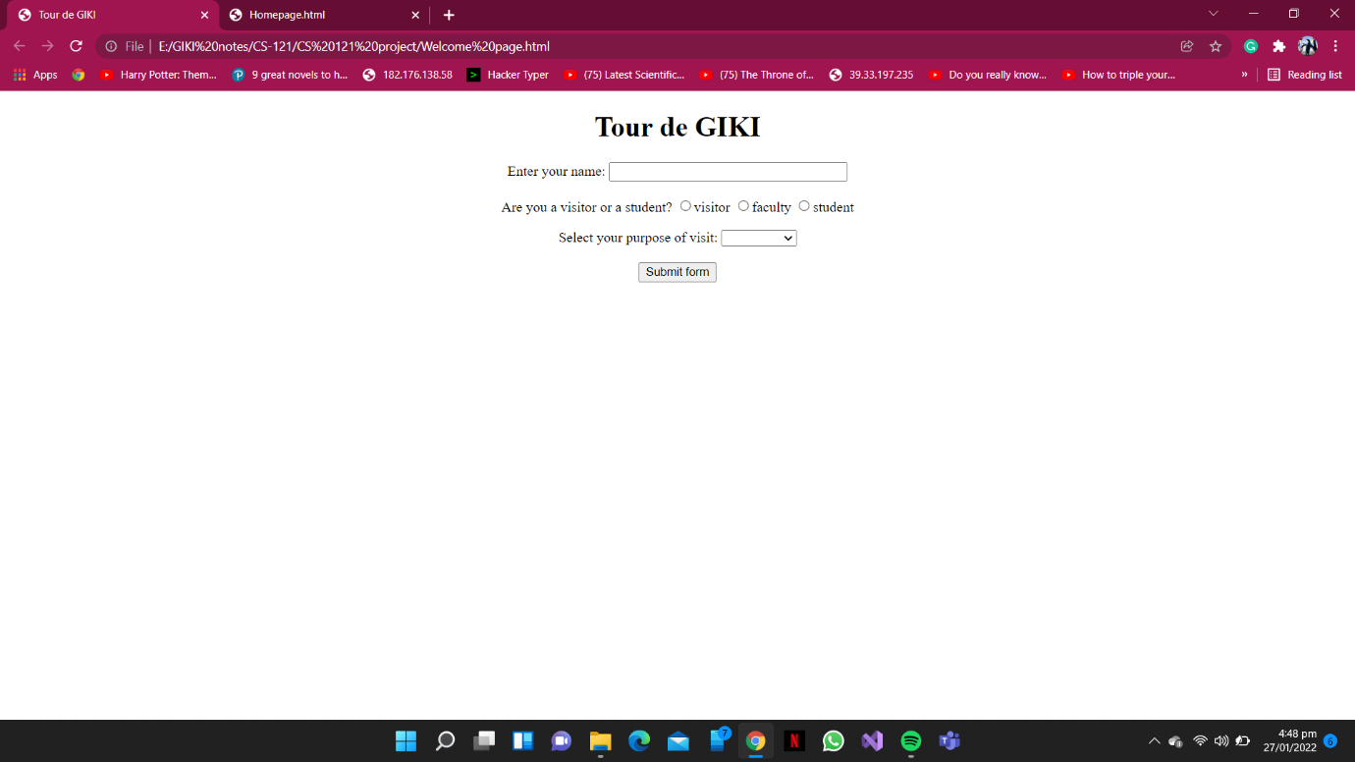

1. Homepage:

When a visitor clicks on the submit button on the welcome page, they are directed to the Homepage. In this page links to the *GIKI’s official websites*  and to three other local webpages have been provided.

The code for the Homepage is given below:

<html>

<head>

    <style>

        body{

   font-size:20px;

            color: rgb(255, 255, 255);

            background-size: cover;

        }

         .box{ width: 1000px;

       float:right;

       border:1px solid none;}

       .box ul li{

           width: 120px;

           float:center;

           margin: 10px auto;

           text-align: center;

       }

   .wd{

           width: 300px;

           height: 539px;

           background-color: black;

           opacity: 10;

           padding: 70px;

       }

       .wd h1{

           text-align: center;

           text-transform: uppercase;

           font-weight: 3000px;

       }

       .wd h4{

           text-align: justify;

           color:darkgray;

           font-weight: 1000px;

       }

   </style>

</head>

<body>

   <div class="box">

    <img src="Auditoriam.jpg">

    <h2><a href="file:///C:/Users/Abdullah/Desktop/file%20for%20project/names%20of%20faculty.html" target="_blank">Faculties</a></h2><br>

    <h2><a href="file:///C:/Users/Abdullah/Desktop/file%20for%20project/Campus%20Market.html" target="_blank">Campus Market</a></h2><br>

    <h2><a href="file:///C:/Users/Abdullah/Desktop/file%20for%20project/Imp%20buildings.html" target="_blank">Other most commonly visited areas</a></h2><br>

</div>

   </div>

   <div class="wd">

<h1> Welcome to Ghulam Ishaq Khan</h1>

<h4> <i>The Ghulam Ishaq Khan Institute of Engineering Sciences and Technology (GIK) is one of the most prestigious engineering institutes of Pakistan. GIK is known the world over for setting a standard of excellence in the field of engineering. </i></h4>

<h2> To visit official website</h2>

<a href="https://giki.edu.pk/#">gik website</a>

</div>

</body>

</html>

The Screenshot for the Welcome page is given below:

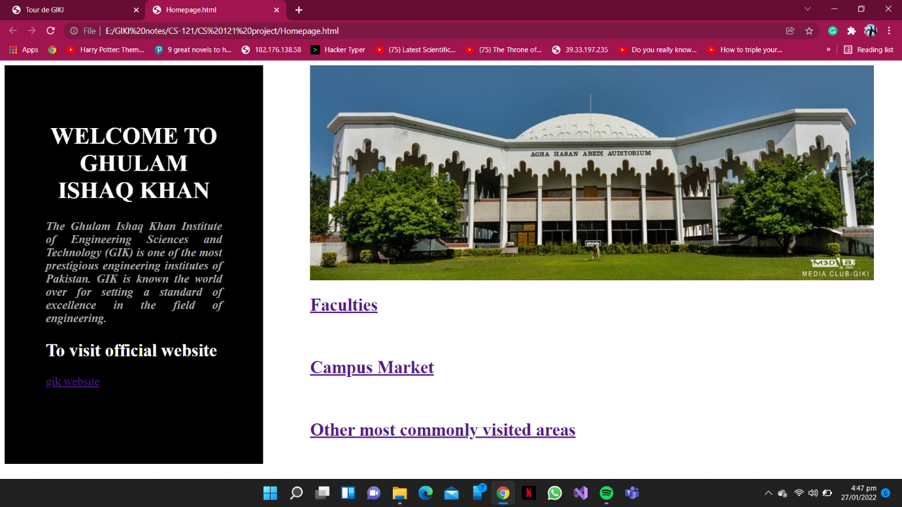

1. Faculties Page:

The visitor can access the Faculties page by clicking on the Faculties button on the Homepage. In the Faculties page, the links to the webpages of three of the major faculties in GIKI have been provided, these links then take the visitor to webpages of the respective faculties.

The code for the Faculties page is given below:

<!DOCTYPE html>

<html>

<body>

    <center>

<h1>Faculties</h1>

    <img src="Capture.PNG" alt="engineering sciences" width="460" height="345">

<h2><a href="file:///C:/Users/Abdullah/Desktop/file%20for%20project/ES%20.html" target="_blank">Faculty of Engineering Sciences</h2><br>

<img src="ME.jpg" alt="mechanical" width="460" height="345">

<h2><a href="file:///C:/Users/Abdullah/Desktop/file%20for%20project/Mechanical%20details.html" target="_blank">Faculty of Mechanical Engineering</a></h2><br>

<img src="electronic and computre.jpg" alt="FCSE" width="460" height="345">

<h2><a href="file:///C:/Users/Abdullah/Desktop/file%20for%20project/Electrical.html" target="_blank">Faculty of Electrical Engineering and Computer Sciences</a></h2><br>

</center>

</body>

</html>

The Screenshot for the Faculties page is given below:

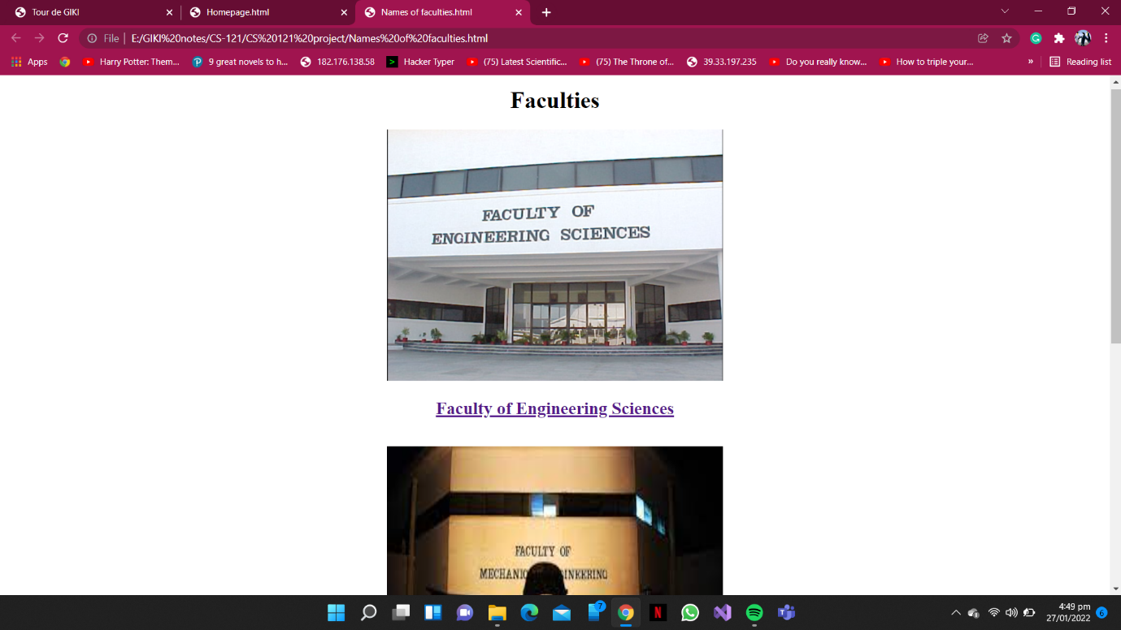

1. Engineering Sciences Page:

By clicking on the Engineering sciences link on the *Faculties page*, *the* visitor is directed to the Engineering Sciences page. Here, they can access the information regarding this faculty, which includes and is not limited to the contact info of the current dean, the internal map and the satellite view of the faculty. The visitor can get the direction to the building of this faculty by clicking on the satellite view map.

The code for the Engineering Sciences page is given below:

<!DOCTYPE html>

<html>

    <body>

        <h1>Engineering Sciences</h1>

        <img src="Capture.PNG" alt="engiineering sciences" width="1500" height="500">

    <h2>The details of Engineering Sciences </h2>

    <p>The future belongs to those who can innovate and possess the knowledge and tools to operate across disciplines. At the Faculty of Engineering Sciences we offer a high-quality inter-disciplinary PEC accredited engineering program that puts the combined power of Mathematics, Physics, Computing, and Engineering in your hands, creating unique opportunities for innovative solutions to modern engineering problems.

        </p>

        <h3>The current Dean of FES is</h3>

        <h4><a href="https://giki.edu.pk/personnel/dr-naveed-r-butt/">Dr.Naveed R.Butt</a> </h4>

        <p>

            <ul>

                <li>naveed.butt@giki.edu.pk</li>

                <li>0938 281026 (Ext. 2535)</li>

                <li>Faculty Lobby</li>

              </ul>

        </p>

        <h4>The internal map of FES is Given Below:  </h4>

        <img src="FES internal.jpeg" alt="FES internal map" width="460" height="350">

        <h3>To get to the location of Building of Engineering Sciences Click on the map below: </h3>

        <a href="https://www.google.com/maps/place/3J9R%2BRW7+Faculty+of+Engineering+Sciences,+Topi,+Swabi,+Khyber+Pakhtunkhwa,+Pakistan/@34.0696924,72.6418991,176m/data=!3m1!1e3!4m5!3m4!1s0x38def93ed2dad897:0x9d911257cb2fb9ea!8m2!3d34.0695858!4d72.6420036"target="_blank">

            <img alt="Qries" src="ES Map.PNG"

            width="460" height="345">

         </a><br>

    </body>

The Screenshots of the Engineering Sciences page page is given below:

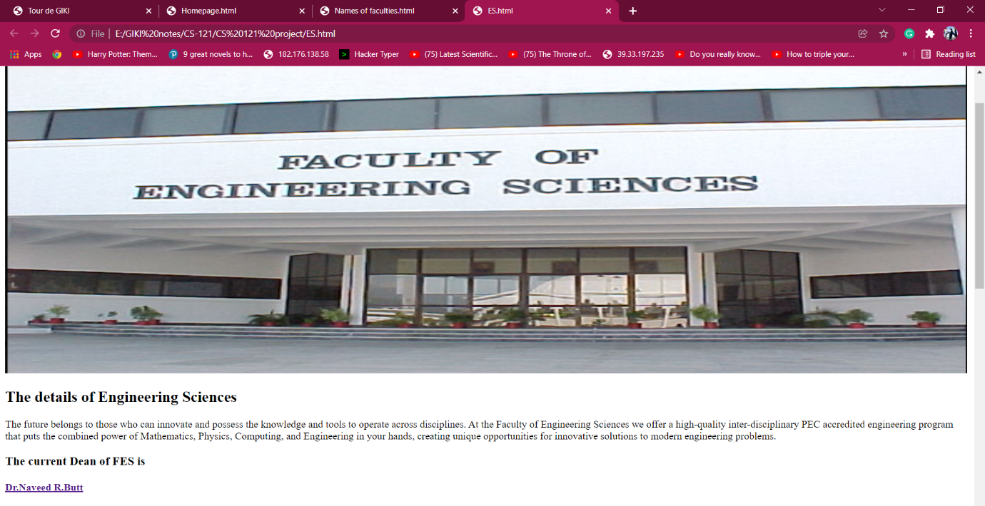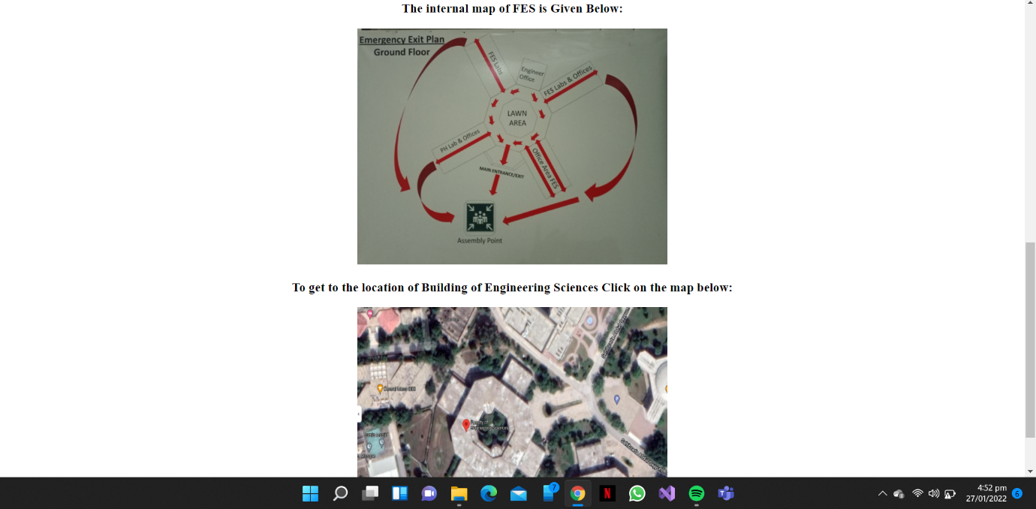

The webpages of the other two faculties have been designed similarly.

1. Important Buildings Page:

This page can be accessed by clinking on the link of the important buildings on the Homepage. Here, the visitor can access the webpages of two of the most visited important building of GIK, which are Admin Building and the Medical Center.

The code for the Important Buildings page is given below:

<!DOCTYPE html>

<html>

    <body>

    <h1>Most Important Buildings of GIKI</h1>

    <p> The following buildings are the two of the most important and most commonly visited buildings in GIK.

        </p>

        <h4>You can access the details of these buildings by clicking on their names below</h4>

        <p><a href="file:///C:/Users/Abdullah/Desktop/file%20for%20project/Admin.html" target="_blank">Admin Block</a></p>

       <p><a href="file:///C:/Users/Abdullah/Desktop/file%20for%20project/MC.html" target="_blank">Medical Center</a></p>

    </body>

The Screenshot for the Important Buildings page is given below:

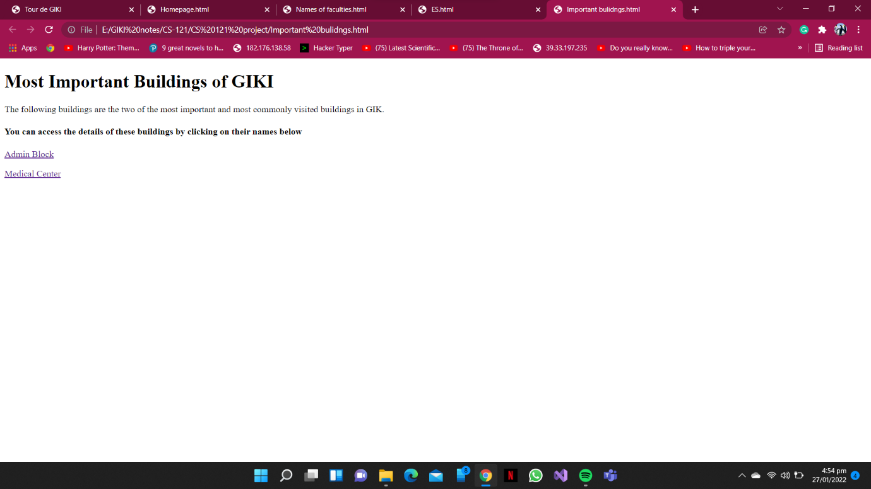

The details of the webpage of one of these important buildings (that is, the Admin block) is given below.

1. The Admin Block Page:

This page can be accessed by clinking on the link of the Admin block on T*he Important Buildings page*. Here the details and the map of the Admin block have been provided.

The code for the Admin Block page is given below:

<!DOCTYPE html>

<html>

    <body>

    <h1>ADMIN BLOCK </h1>

    <img src="ADMIN.jpg" alt="Admin block" width="1500" height="750">

    <p>The Administration block of the Institute includes the offices of the Rector, Pro-Rector (Academic), Dean (Student Affairs), Controller of Examinations, Admission , Administration, Finance and other allied offices.

        </p>

        <h3>To get to the location of Admin Block Click on the map below: </h3>

        <a href="https://www.google.com/maps/place/Administration+Block,+Topi,+Swabi,+Khyber+Pakhtunkhwa,+Pakistan/@34.0682036,72.643087,178m/data=!3m1!1e3!4m5!3m4!1s0x38def9396bc5d5fb:0x57b73c88e30d4d15!8m2!3d34.068242!4d72.6436434"target="_blank">

            <img alt="Qries" src="ADMIN map.PNG"

            width="460" height="345">

         </a><br>

    </body>

The Screenshots for the Admin Block page is given below:

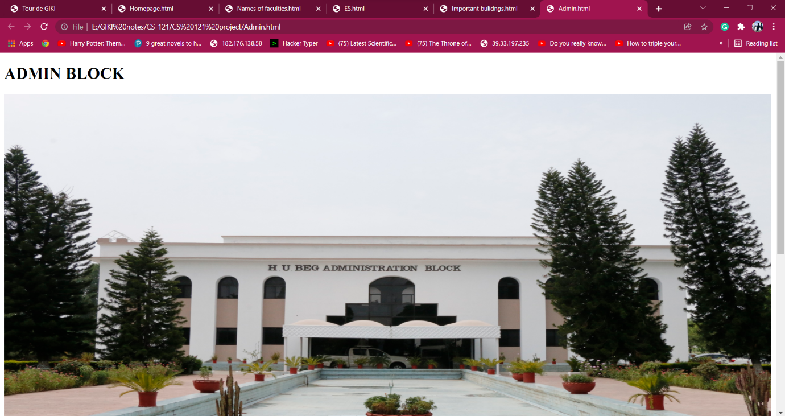 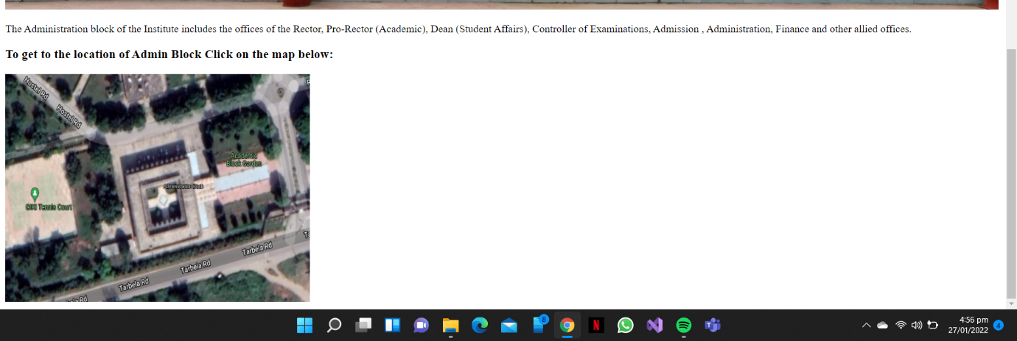

Similarly, the Page of the Medical Center has been created.

1. The Ayan Garden Page:

This page can be accessed by clicking on the Ayan garden link on the Campus Market page, which in turn can be accessed from the Important building page. Here, like all other restaurants pages, menus and the map are provided.

The code for the Admin Block page is given below:

<!DOCTYPE html>

<html>

    <body>

    <h1>Ayan Garden </h1>

    <img src="Ayyan logo.JPeG" alt"Ayan logo" width="747" height="400">

    <img src="Ayyan lawn.jpeg" alt"Ayan lawn" width="747" height="400">

    <h3> The menu of Ayan Garden is given below:     </h3>

    <img src="Ayyan menu 1.jpeg" alt"Ayan Menu 1" width="460" height="345">

    <img src="Ayyan menu 2.jpeg" alt"Ayan Menu 2" width="460" height="345">

    <img src="Ayyan menu 3.jpeg" alt"Ayan Menu 3" width="460" height="345">

    <img src="Ayyan menu 4.jpeg" alt"Ayan Menu 4" width="460" height="345">

    <h3> To get the direction to Ayan Garden click on the map given below:     </h3>

    <a href="https://www.google.com/maps/place/Ayan+Hotel+and+BBQ,+GIKI/@34.0710721,72.6469597,136m/data=!3m1!1e3!4m12!1m6!3m5!1s0x38def93c5797c0d7:0x95445985be9ab625!2sGhulam+Ishaq+Khan+Institute+of+Engineering+Sciences+and+Technology!8m2!3d34.0691452!4d72.6441351!3m4!1s0x38def93c634d7b87:0xd85fe56dc00be756!8m2!3d34.0709913!4d72.6473155"target="_blank">

        <img alt="Qries" src="ayyan map.PNG"

        width="460" height="345">

     </a><br>

The Screenshots for the Ayan Garden page is given below:

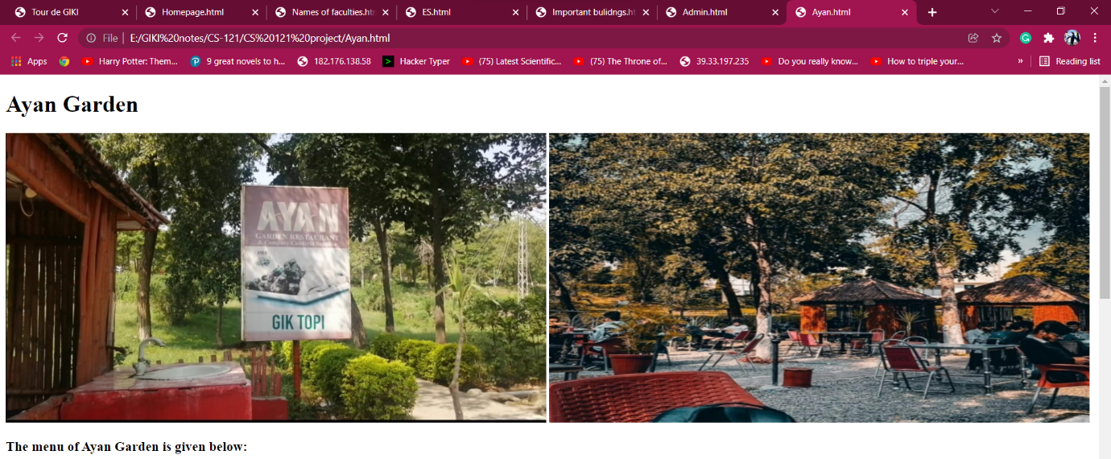 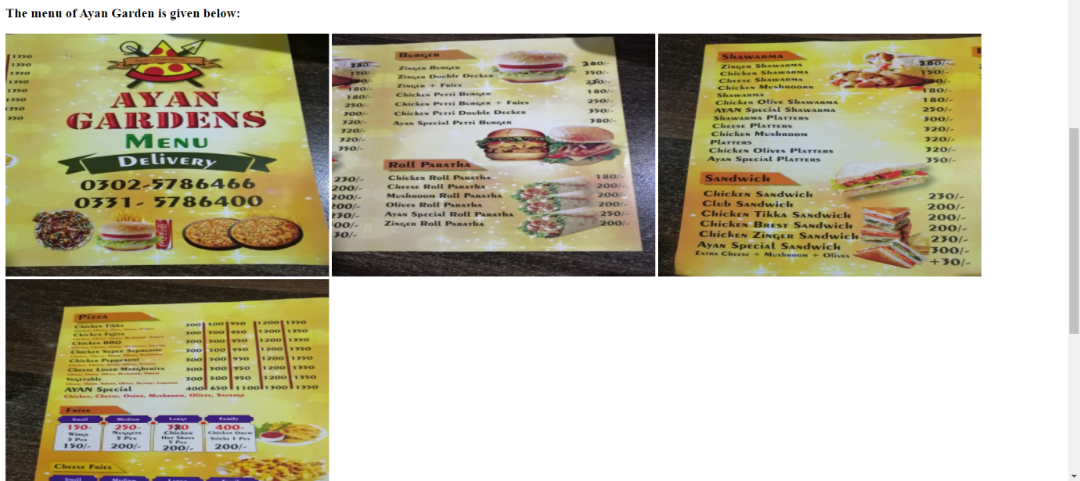 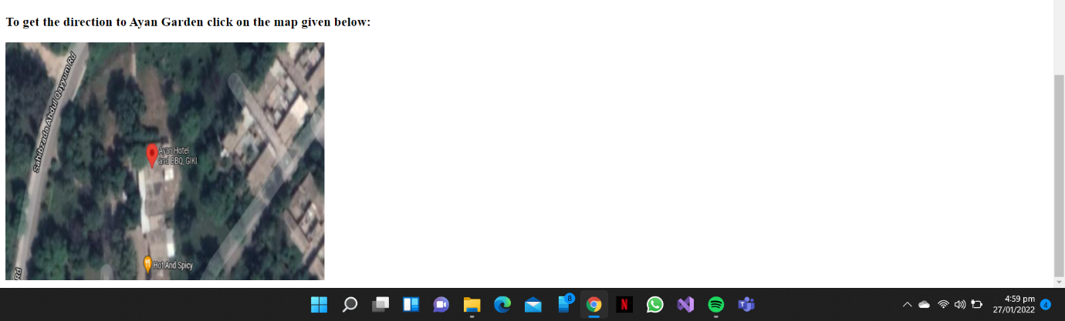

Project Details:

Course Instructor:

Ma’am Aqsa Rahim.

Creators:

1. Rafay Mustafa reg#2021527.
2. Abdullah Habib reg#2021033.
3. Salman Ahmed Khan reg#2021562.

Course: CS-121.